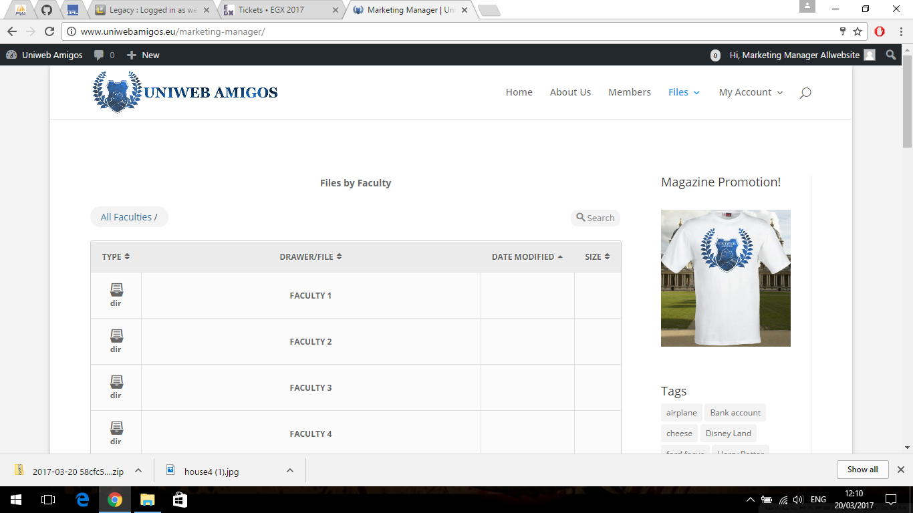

First we have the marketing manager home dashboard which has:

* Access to all the four faculty’s upload files
* Then below it has a showing of all the files that have been latest uploaded or modified
* Then there is also the magazine shirt promotion to for our users to look at
* There are also a few features here that allow you to select all the files and Download them into a zip folder from the recent uploaded and modified and from all of the faculties

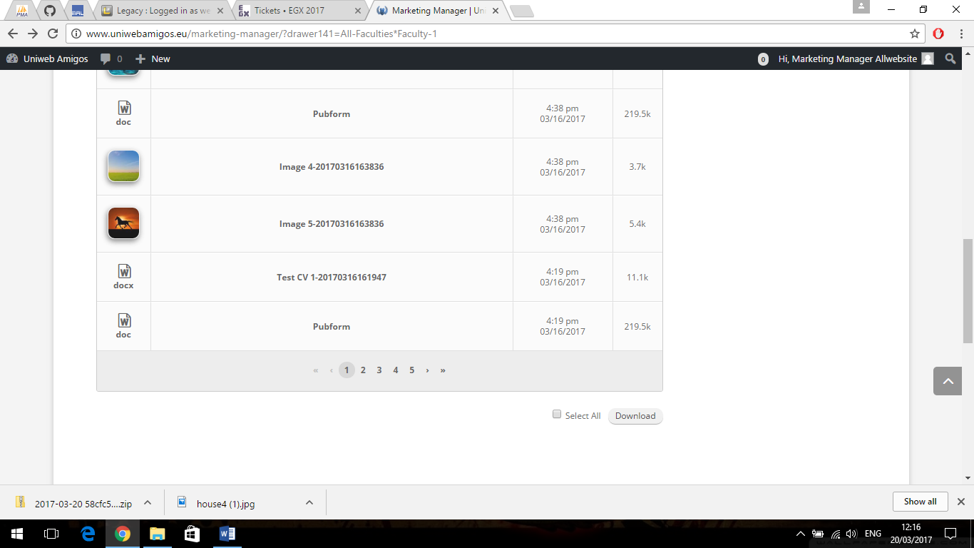

* Then within each of the faculties the manager can see all of files that have been uploaded in two directories and allowing the manger to download these file into a zip file by either clicking the one they want or select all and downloading them into a zip folder.

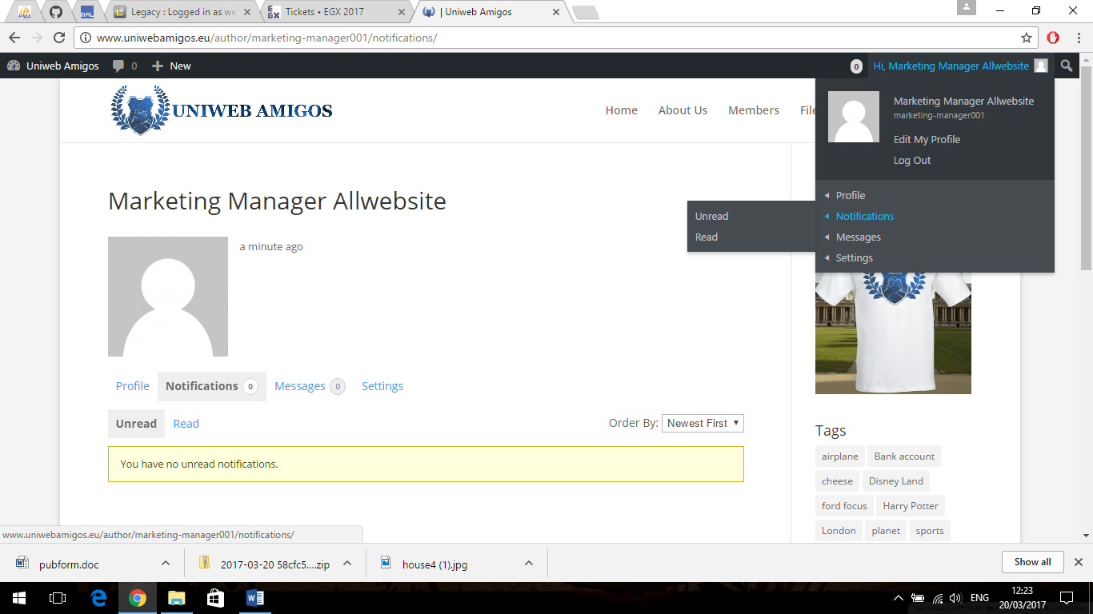

Then within the marketing manager there is the top of the dashboard that allows you to edit the profile and also to view any nonfictions or messages that they may receive.

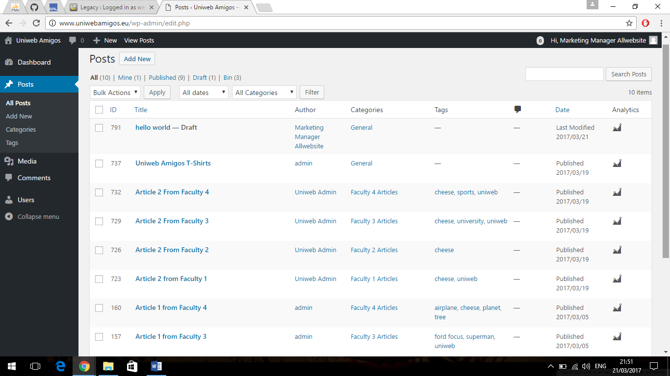

* In part of the dashboard the manager can
* View all the published articles that have been added to the home page
* Edit them and then be able to publish the ones that have been set as draft

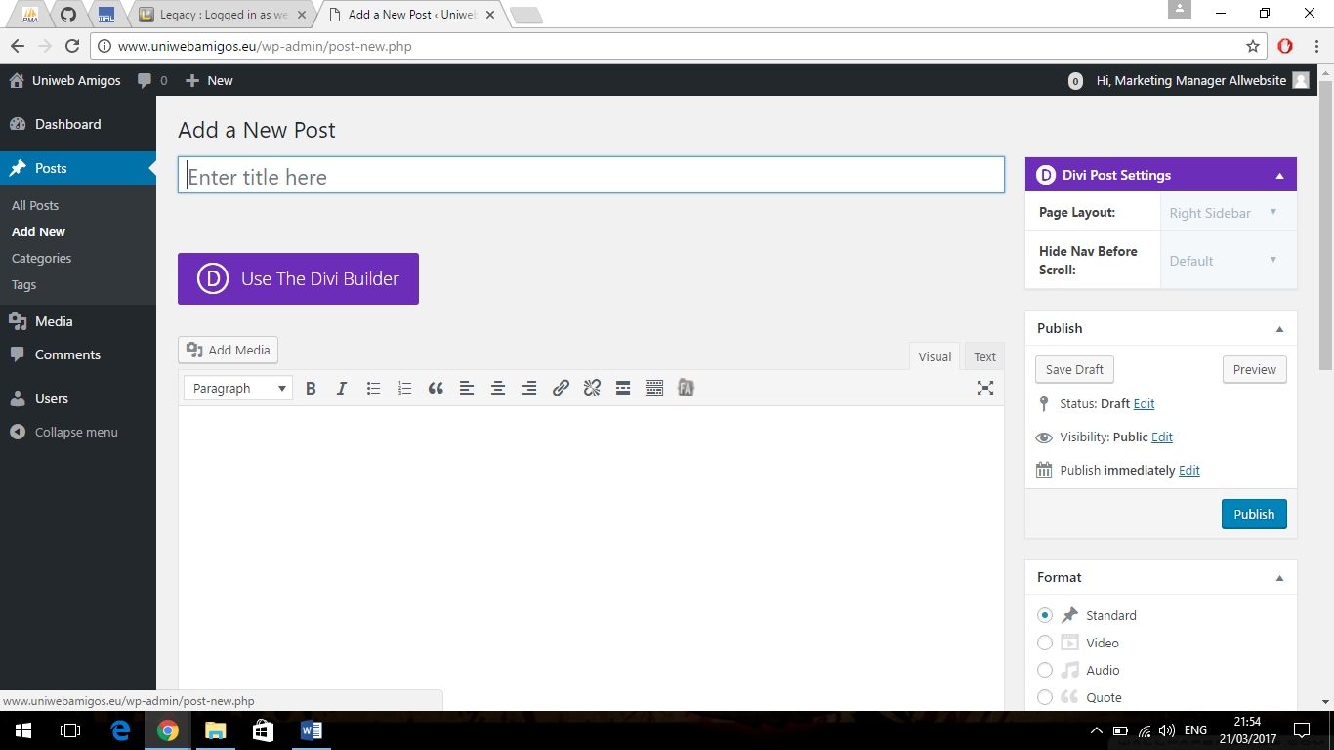

Within this part the manager can:

* Can publish an article to the homepage
* Include an image of media

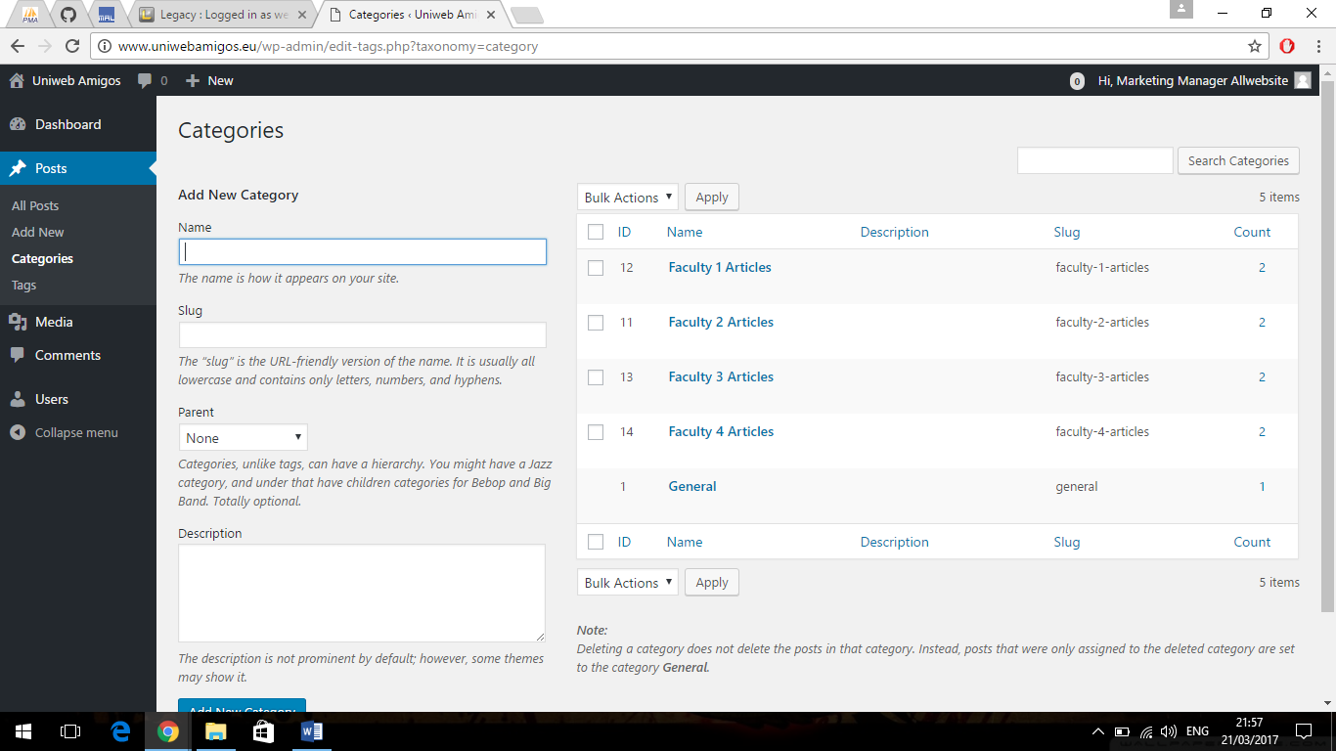

With this they can:

* Add a new category for the homepage
* Seen on the right are the current articles that are already on the homepage

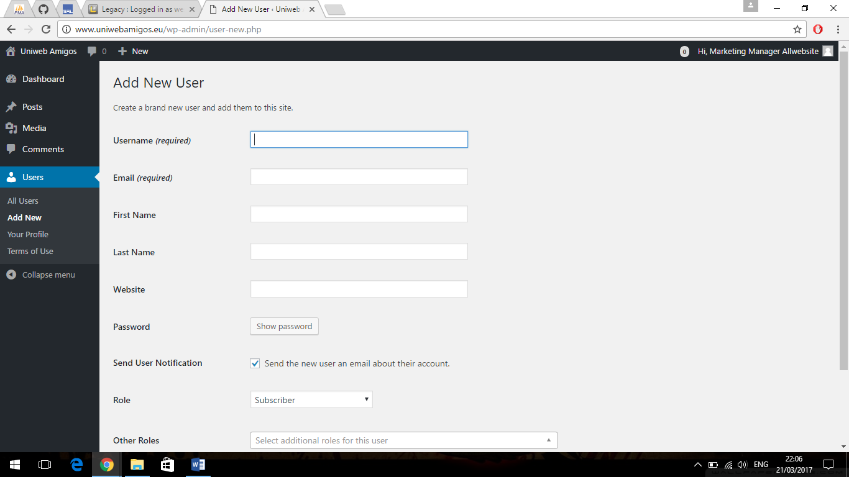

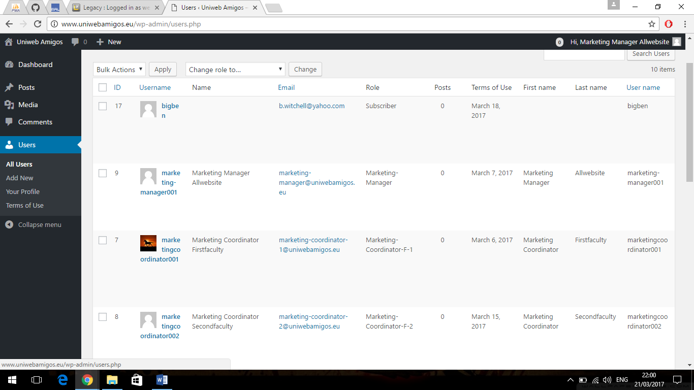

The manger can also:

* Add new users
* View and manage current users

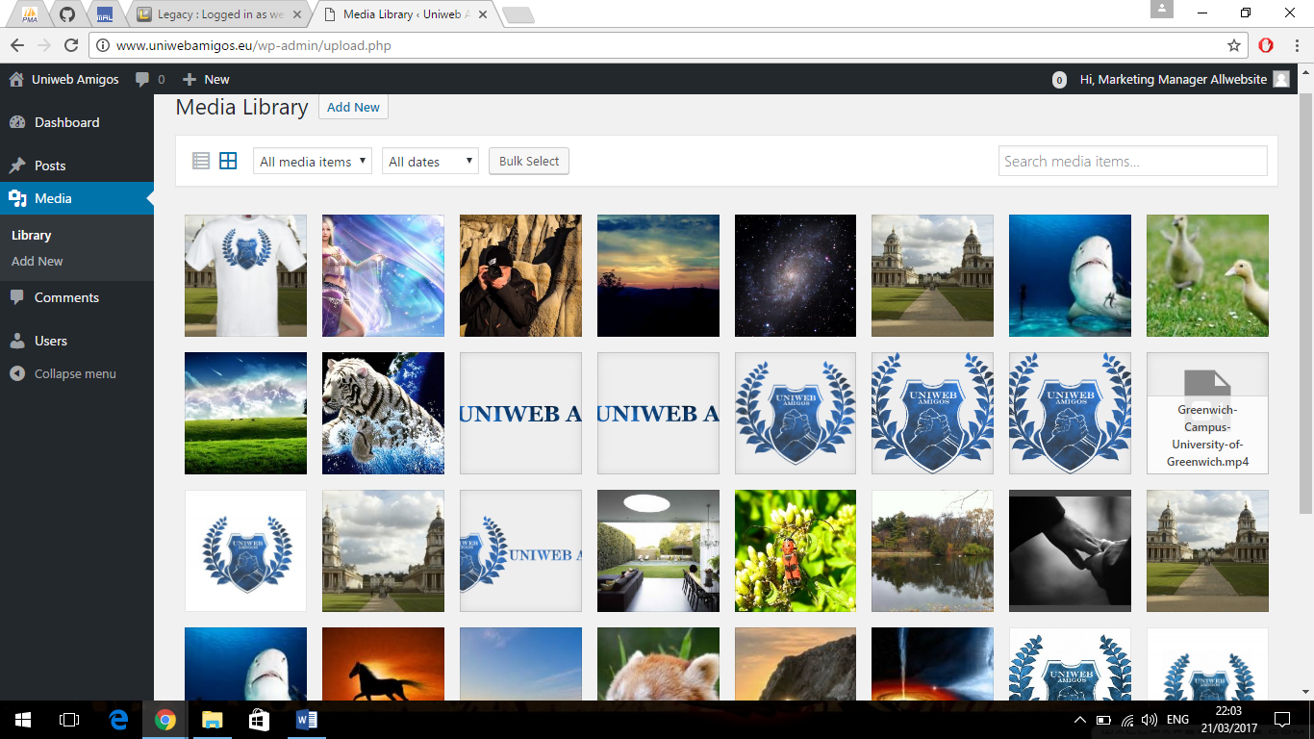

Then the manager can also manage the image library by adding and removing of images